 | a place of mind  THE UNIVERSITY OF BRITISH COLUMBIA | Department of Curriculum and Pedagogy  Faculty of Education  University of British Columbia  2125 Main Mall, Vancouver, B.C., V6T 1Z4

To: [name], Superintendent, SD #7
From: Kieran Forde, Jillianne Code, and Anthony Clarke
Re: Gathering information on social media policies - Gratitude
Date: October 30, 2020

Dear Superintendent [name]:

Thank you very much for your prompt response to our inquiry. We will be sure to share the results of our work with you in early 2021.

I thought you and others in your district may be interested in my master’s degree graduating paper which includes a section directly related to social media policies, as well as other issues of concern around regulation and teacher professionalism.

- Regulation of Teacher Professionalism and Social Media: An Analysis of Disciplinary Outcomes and Teacher Candidates’ Self-Regulation in British Columbia https://open.library.ubc.ca/cIRcle/collections/graduateresearch/42591/items/1.0380582

Many thanks again. We wish you and all in your district the very best as we continue our work in teaching and learning during these challenging times.

Sincerely,

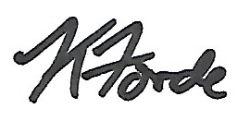
Kieran Forde, Ph.D. Student, UBC
kieran.forde@mail.ubc.ca
Provost Office Fellow in Online Learning

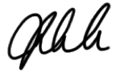
Jillianne Code, Assistant Professor, Media & Technology Studies Education, UBC
jillianne.code@ubc.ca

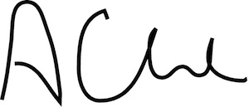
Anthony Clarke, Full Professor, UBC
anthony.clarke@ubc.ca

