 | a place of mind  THE UNIVERSITY OF BRITISH COLUMBIA | Department of Curriculum and Pedagogy  Faculty of Education  University of British Columbia  2125 Main Mall, Vancouver, B.C., V6T 1Z4

To: [name], Superintendent, SD #
From: Kieran Forde, Jillianne Code, and Anthony Clarke
Re: Gathering information on social media policies
Date: October 28, 2020

Dear Superintendent [name]:

My name is Kieran Forde. I am a second-year doctoral student at UBC. I am working with Professors Jillianne Code and Anthony Clarke in the Department of Curriculum and Pedagogy.

Jillianne, Tony, and I are trying construct an overall picture of the school district employee social media policies.

We hope that the information we gather will help all educators throughout the province to be better placed to respond to this ever changing and important dimension of the teaching profession.

A quick scan of your district website doesn’t immediately show any current policy or procedures related to social media.

We were wondering if perhaps you, or someone else in your office, could direct us to any relevant policy documents we might refer to or let us know if there is policy related to employee use of social media under development. We would be happy to include this information alongside the policy documents we have complied from other school districts.

We thank you for your time and effort and would be happy to send you a draft copy of our work which we hope to complete in early New Year.

Many thanks,

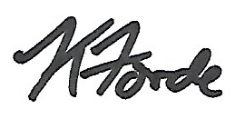
Kieran Forde, Ph.D. Student, UBC
kieran.forde@mail.ubc.ca
Provost Office Fellow in Online Learning

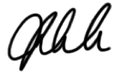
Jillianne Code, Assistant Professor, Media & Technology Studies Education, UBC
jillianne.code@ubc.ca

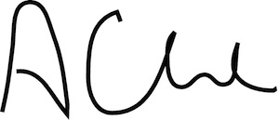
Anthony Clarke, Full Professor, UBC
anthony.clarke@ubc.ca

