 | a place of mind  THE UNIVERSITY OF BRITISH COLUMBIA | Department of Curriculum and Pedagogy  Faculty of Education  University of British Columbia  2125 Main Mall, Vancouver, B.C., V6T 1Z4

To: [name], Superintendent, SD #
From: Kieran Forde, Jillianne Code, and Anthony Clarke
Re: Gathering information on social media policies
Date: October 25, 2020

Dear Superintendent [name]:

My name is Kieran Forde. I am a second-year doctoral student at UBC. I am working with Professors Jillianne Code and Anthony Clarke in the Department of Curriculum and Pedagogy.

Jillianne, Tony, and I are trying construct an overall picture of the school district employee social media policies.

We hope that the information we gather will help all educators throughout the province to be better placed to respond to this ever changing and important dimension of the teaching profession.

A quick scan of your district website shows that your current social media policy for employees is best articulated in [hyperlink to policy on SD website] (year).

We were wondering if perhaps you, or someone else in your office, could confirm that this is most current version of the document and if there are any other relevant policy documents we might refer to.

We thank you for your time and effort and would be happy to send you a draft copy of our work which we hope to complete in early New Year.

Many thanks,

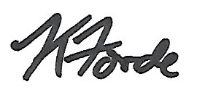
Kieran Forde, Ph.D. Student, UBC
kieran.forde@mail.ubc.ca
Provost Office Fellow in Online Learning

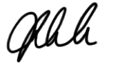
Jillianne Code, Assistant Professor, Media & Technology Studies Education, UBC
jillianne.code@ubc.ca

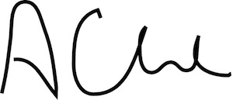
Anthony Clarke, Full Professor, UBC
anthony.clarke@ubc.ca

